**SIMPLE NETWORK LATENCY TESTER**

Latency refers to the time it takes for a data packet to travel from its source to its destination. It is a critical measure in network performance, impacting how quickly information is transmitted and received. To calculate latency, you typically send a series of packets from the client to the server using ICMP ping requests. By measuring the time interval between sending the packet and receiving its acknowledgment, you can determine the round-trip time (RTT). This process is repeated multiple times to account for variations, and the average of these measurements is used to represent the latency. Additionally, packet loss can be assessed to understand the reliability of the connection.

Program:

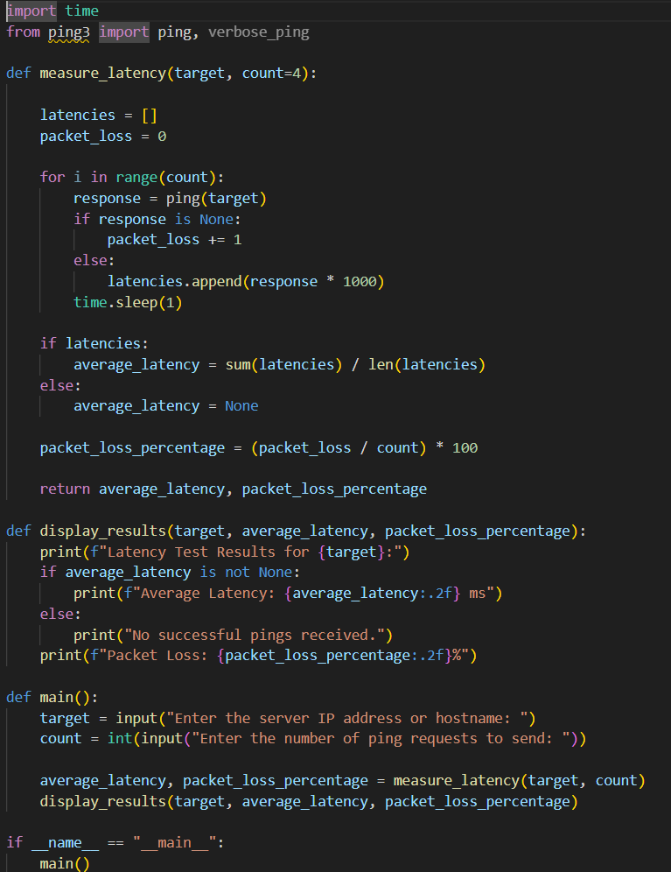

O/P:

